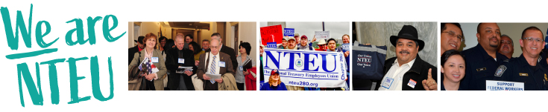
Happy Labor Recognition Week!
Labor Recognition Week is here! It’s a celebration all our own, and a time to honor you and your contributions as a unionized frontline federal employee. Even in difficult times, your dedication does not waver. You stay focused on your important work because Americans rely on you.
Over the years, your support of NTEU has empowered us to secure a long list of workplace gains while blocking threats to your pay, retirement and benefits. These successes would not have been possible without large numbers of federal employees coming together for a single purpose: to improve the federal workplace. And that is a reason to celebrate!
We want to make sure you know that we appreciate you for everything you do as a federal employee. Our country wouldn’t be what it is without the skill, dedication and commitment to public service you bring to work every day.
Thank you for your membership in NTEU.

