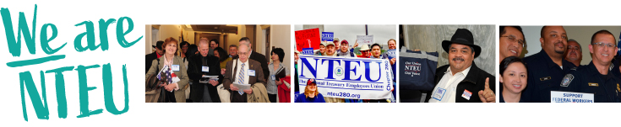

This week is all about YOU!

Chapter [NUMBER] is hosting a Labor Recognition Week celebration—and you’re the special guest.

Join us!

WHO: NTEU Chapter [Number]
WHAT: Our Labor Recognition Week Celebration
WHEN: [Date and Time]
WHERE: [Provide teleconference link if the event is virtual or meeting location]

[INCLUDE ANY ADDITIONAL INFORMATION HERE, SUCH AS GUEST SPEAKERS, REFRESHMENTS, RAFFLES OR GIVEAWAYS, OR OTHER INCENTIVES FOR ATTENDING]

For more information, contact Chapter [NUMBER] at [CHAPTER LEADER’S NAME AND EMAIL AND/OR PHONE INFORMATION].

