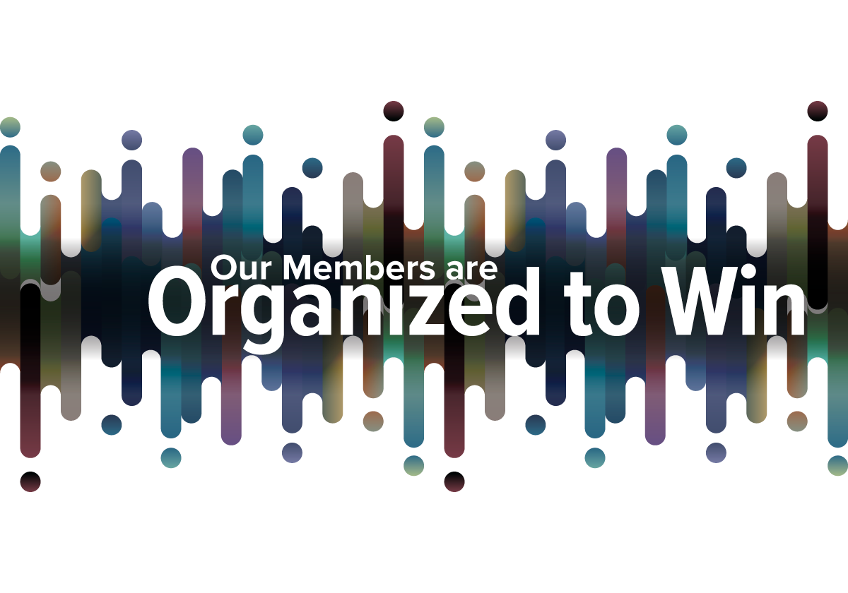**You’re invited**

**It’s Labor Recognition Week and Chapter [NUMBER]  
is holding a celebration in honor of YOU.**

**Take a break as we thank you for your contributions   
as a federal employee and NTEU member.**

**WHO:** NTEU Chapter [Number]

**WHAT:** A Labor Recognition Week Celebration

**WHEN:** [Date and Time]

**WHERE:** [Provide teleconference link if the event is virtual or meeting location]

[INCLUDE ANY OTHER INFORMATION SUCH AS RAFFLES, GUEST SPEAKERS OR INCENTIVES FOR ATTENDING]

For more information, contact Chapter [NUMBER] at [LEADER NAME AND CONTACT INFORMATION].