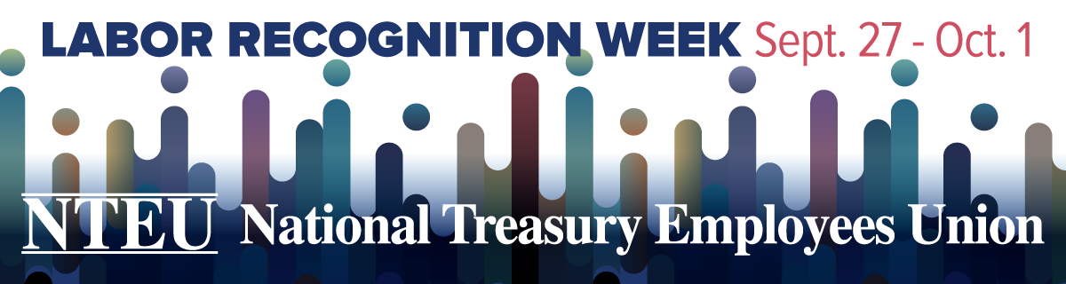

This week is Labor Recognition Week, our annual celebration of your contributions as a unionized frontline federal employee. While we can’t mark the occasion together, Chapter [NUMBER] didn’t want to miss the chance to tell you how much we appreciate you. And there’s a lot to be grateful for this year.

One week is simply not enough time to acknowledge all you’ve done these past months for our country. The American people need you on the job, and you are there for them, no matter your personal challenges.

As an NTEU member, your support has given us the power and clout to secure meaningful workplace gains and block threats to your retirement and paycheck. These successes would not have been possible without large numbers of federal employees coming together for a single purpose: to improve the federal workplace. It’s what being Organized to Win is all about.

These are busy, stressful times, but we hope you’ll take a break to join us for a much-deserved celebration. This year, we are: [INSERT ANY LOCAL ACTIVITIES OR RECOGNITION THE CHAPTER HOSTS, INCLUDING ANY VIRTUAL EVENTS.]

We are looking forward to the day when we can celebrate our accomplishments in-person—or even stop by just to check in. Until then, remember that Chapter [NUMBER] is here to support you. Reach out if you need help, have questions, want to become more active in the chapter, or simply to say hello.

**Chapter Leaders:** [Name of chapter president or active stewards]

**Chapter Email:** [email address(es)]

**Chapter Resources:** [chapter website, if applicable; Facebook; Twitter, etc.]