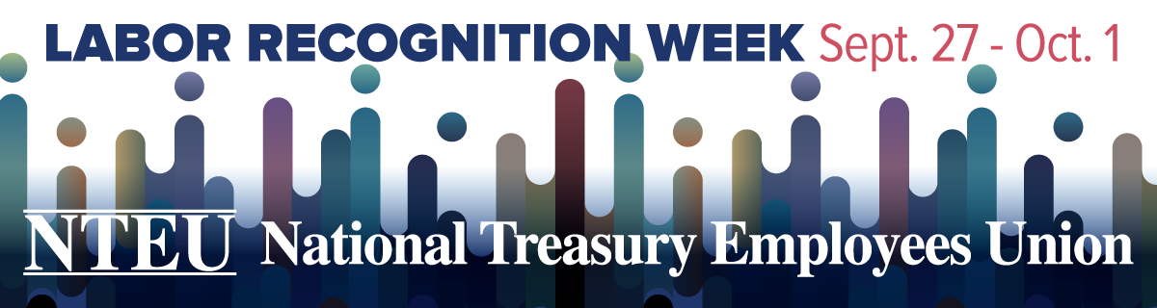

**Sample Script**

**Chapter LRW Video**

Hello NTEU Chapter [number]. I am [name], your chapter president.

This week at NTEU we’re all about celebrating you. That’s right, it’s Labor Recognition Week, when NTEU celebrates the contributions of frontline union employees.   
  
One week is hardly enough time to fully celebrate the impact you have on the lives of every American—or all we have been able to accomplish thanks to the support of members like you. But I hope that LRW is a reminder of how much we appreciate you, especially when we can’t thank you in-person right now.

[Insert any special activities the chapter has planned]

As always, Chapter [number] appreciates your membership and is here for you.

Happy Labor Recognition Week and thank you!