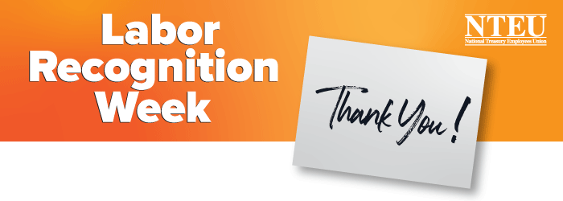
You’re Invited!

It’s Labor Recognition Week and Chapter [number]
is holding a virtual celebration in honor of YOU.
Be our guest as we thank you for your contributions
to our country and for your support of our union.

Who: NTEU Chapter [number]
What: A Labor Recognition Week Virtual Celebration
When: [Date and time]
Where: Join us from wherever you are by clicking here: [Provide teleconference link]
[Include any other information such as raffles or incentives for attending]

We may not be together right now, but we are NTEU United!

For more information, contact Chapter [number] at
[leader name and contact information].

nteu.org

