It’s Labor
Recognition Week!
Chapter [number] is
thanking our members
for everything you do.
As an NTEU member, your support helps us stand up for you and all our members.
As a [your agency] employee, you have delivered for the American people during this challenging time.
To show our appreciation, we are [insert any local activities or recognition the chapter is hosting, including any virtual events, gifts or raffles].

Thank you—and remember, we are here for you.
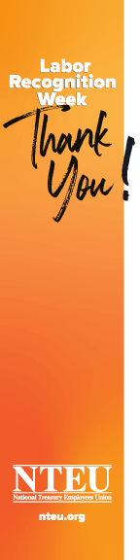
[Chapter inserts leader name(s) and contact information]

