**Getting the Best Results When Filming Yourself with a Smartphone**

**Important: Position your phone horizontally. Always film horizontally!**

**Tips**

* Film horizontally—this is important due to the landscape (horizontal) format of computer monitors and TVs
* If possible, select a wall or space with an uncluttered, neutral background
* Check for strong shadows that may be behind you—position yourself farther away from the wall
* When framing your shot, position yourself in the horizontal center giving yourself a bit of headroom (don’t cut off the top of your head) and aim for chest up

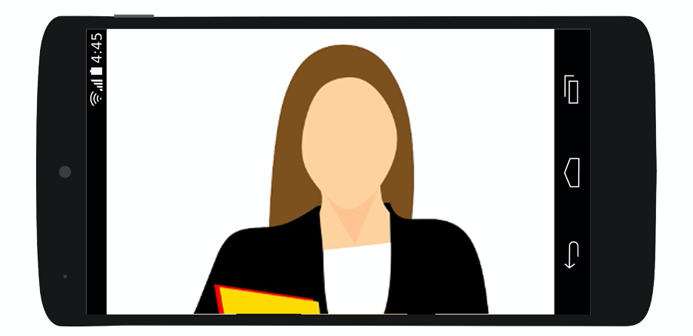

* Set up your smartphone on a stable surface or use a tripod with your phone level with or slightly above your eye line
* Try not to watch yourself but look at the lens—this helps you not obsess about yourself and it gives the appearance that you’re looking at your audience
* If you’re using a script, tape it up as close to your phone as possible—perhaps, tape it on your phone but don’t cover the lens (then you don’t have to watch yourself)
* Rehearse a couple times before your final take

**Lighting**

* Set yourself up facing the light source and slightly off center to avoid squinting and having the light wash out your face

* Avoid strong light sources (lamps, windows, etc.) directly behind you

* Utilize natural light, if available
* Avoid strong overhead lights, they create unflattering shadows and hot spots on foreheads, cheeks and noses
* Check yourself on screen and reposition if necessary

**Audio**

* Locate a quiet space to film—be aware of background noises such as conversations, traffic, TVs, appliances, etc., the microphone will pick up sounds that you tune out
* Use an external microphone or headphones with a microphone, if you have them—it’s ok if they show in the video
* If you are not using an external microphone or headset, position yourself within three feet of your smartphone

**Congrats, you’re ready for your close up!**