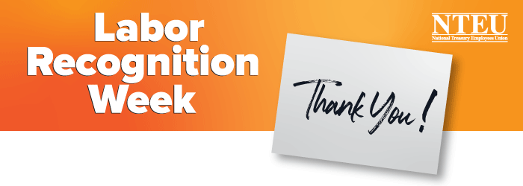
NTEU Chapter [number]
This week NTEU marks Labor Recognition Week. Since we can’t celebrate together (your safety comes first!) we at Chapter [number] thought we would send a quick note to tell you how much we appreciate each of you.
As an NTEU member your support helps us stand up for you and all NTEU members. Over the years we have fought for and won a lot of workplace gains, some of which are under fire right now. Together, we are a united front in fighting back. Thank you for that.
As a federal employee at [agency] your work matters. Taking time to honor that work is why we celebrate Labor Recognition Week. So much of what federal employees do happens under the radar and many Americans do not understand or appreciate your efforts. We do—at the chapter and at the national level.
[Insert any local activities or recognition the chapter is hosting, including any virtual events.]
We don’t know when the health risks will fade away and we can spend time together in person, but we are very much looking forward to that day. Until then, know that our chapter is still on the job, we are here for you and we encourage you to reach out to let us know you need some help, or want to step up and become a more active member or simply to say hello.
Thank you for your federal service and your union support. Stay safe and be well.
Your Chapter [number] leaders and stewards
[add chapter website, Facebook page, or email address]

